DOMAIN: Manufacturing
CHOSEN COMPANY: TATA MOTORS
DATE: 15-05-2026

GROUP MEMBERS:
- Nithin V Anil



Section 1 — Business Understanding & DBMS Foundations

Integrated Operations Analysis: Manufacturing Sector

The manufacturing industry is one of the strongest pillars of the global economy, responsible for transforming raw materials into finished products across sectors such as automobiles, electronics, and heavy machinery. Modern manufacturing has evolved rapidly with technologies like automation, Artificial Intelligence (AI), IoT, robotics, and smart factory systems. These technologies help improve operational efficiency, product quality, production speed, and supply chain management. Manufacturing companies are increasingly focusing on sustainability, digital transformation, and data-driven decision-making to remain competitive in global markets.

Data scientists and data analysts play a major role in improving manufacturing operations through production analysis, predictive maintenance, inventory optimization, and quality monitoring. By analyzing machine data, supply chain records, and operational reports, they help companies reduce downtime, improve efficiency, and optimize manufacturing costs. Advanced analytics and Industry 4.0 technologies also support better forecasting, operational planning, and real-time decision-making, helping manufacturers build smarter and more efficient production systems.

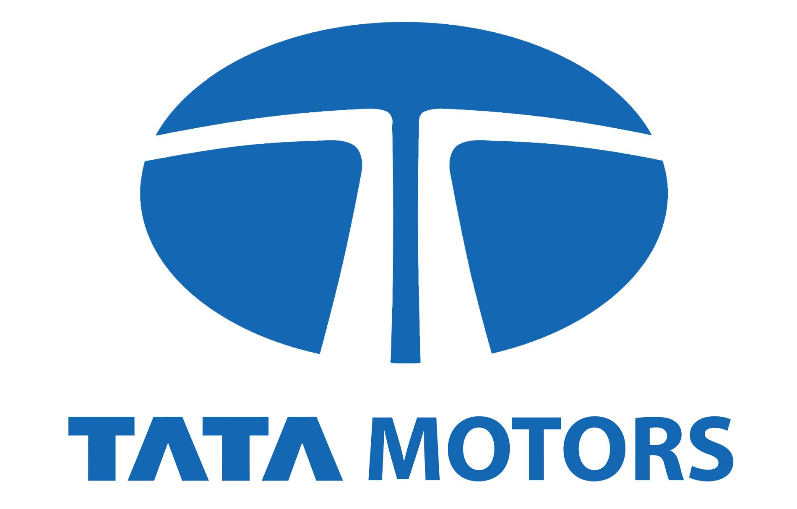

1.1 Product Dissection: Tata Motors

Popularity: Tata Motors is one of India’s leading automobile manufacturing companies with a strong presence in passenger vehicles, commercial trucks, buses, and electric vehicles. The company is widely recognized for innovation, reliability, and its rapidly expanding EV portfolio. Models such as Nexon EV, Punch EV, and Tiago EV have significantly increased Tata Motors’ popularity in the Indian electric vehicle market. Its strong manufacturing network and global operations have made it one of the most trusted automobile brands in India.
Impact: Tata Motors has contributed significantly to the growth of the Indian automobile and manufacturing industry through advanced manufacturing technologies, automation systems, and sustainable mobility initiatives. The company uses robotics, AI-based quality inspection, and smart factory technologies to improve operational efficiency and product quality. Tata Motors has also increased investments in EV manufacturing facilities and charging infrastructure partnerships to support India’s transition toward electric mobility.
Relevance: Tata Motors remains highly relevant in modern manufacturing because of its adoption of Industry 4.0 technologies such as IoT-enabled systems, predictive maintenance, automation, and real-time production monitoring. The company continuously focuses on digital transformation, sustainability, and operational efficiency to remain competitive in the automotive industry. Its growing investment in electric vehicles and smart manufacturing practices makes it a strong example of modern industrial transformation.

Core Features and Functionalities
Tata Motors is one of India’s leading automobile manufacturing companies, known for its strong production capabilities, advanced manufacturing systems, and growing focus on smart mobility solutions. The company uses modern technologies, automation, and data-driven operations to improve manufacturing efficiency, product quality, and customer satisfaction.

1. Advanced Manufacturing Facilities:
Tata Motors operates modern manufacturing plants equipped with robotic assembly lines, automated machinery, and smart factory systems to improve production speed, precision, and operational efficiency.
2. Electric Vehicle (EV) Production:
The company has significantly expanded its electric vehicle manufacturing capabilities through models like Nexon EV, Tiago EV, and Punch EV, supporting sustainable transportation and green mobility initiatives.
3. Supply Chain and Inventory Management:
Tata Motors uses digital supply chain systems and real-time inventory tracking to manage raw materials, automobile parts, and vehicle production efficiently while reducing operational delays.
4. Quality Control Systems:
The company implements strict quality testing and inspection processes during manufacturing to ensure vehicle safety, durability, reliability, and performance standards.
5. Research and Development (R&D):
Tata Motors continuously invests in research and innovation to develop new vehicle technologies, improve fuel efficiency, enhance vehicle safety, and support future mobility solutions.
6. Smart Manufacturing and Automation:
The company uses IoT-enabled systems, predictive maintenance tools, AI-driven monitoring, and industrial automation technologies to optimize manufacturing operations and reduce machine downtime.
7. Customer-Centric Product Portfolio:
Tata Motors offers a wide range of passenger vehicles, electric vehicles, commercial vehicles, buses, and trucks to serve different customer segments and market demands.
8. Sustainability and Green Manufacturing:
The company focuses on sustainable manufacturing practices such as energy-efficient production systems, waste reduction initiatives, and eco-friendly vehicle development to reduce environmental impact.
9. Digital Transformation Initiatives:
Tata Motors has adopted digital technologies and data analytics systems to improve production planning, operational monitoring, supply chain coordination, and business decision-making processes.

Contribution to Success and Operational Efficiency
● Manufacturing Efficiency: Automated production systems and smart factory technologies help improve productivity, reduce downtime, and optimize resource utilization.

● Product Innovation: Continuous research and development support the launch of advanced, safe, and technologically improved vehicles in the market.

● Customer Satisfaction: Strong quality control measures and a diverse product portfolio help Tata Motors maintain customer trust and market competitiveness.

● Sustainability Focus: Electric vehicle expansion and green manufacturing practices strengthen the company’s position in the future mobility sector.

● Data-Driven Operations: Real-time monitoring systems, predictive maintenance, and digital supply chain management improve operational efficiency and decision-making.

These features and functionalities collectively help Tata Motors maintain strong manufacturing performance, technological advancement, operational efficiency, and long-term growth in the automotive industry.

Real-World Manufacturing Challenges
Tata Motors operates in a highly competitive automobile manufacturing industry where operational efficiency, supply chain management, product quality, and technological innovation are critical for success. The company addresses several real-world manufacturing challenges through automation, digital transformation, smart manufacturing systems, and sustainable mobility initiatives.

Real-World Manufacturing Problems Addressed by Tata Motors :

1. Production Delays and Manufacturing Downtime:
- Problem: Machine failures, unplanned maintenance, and supply chain disruptions can slow down production processes and reduce manufacturing efficiency.

- Solution: Tata Motors uses predictive maintenance systems, IoT-enabled monitoring, and automated production planning tools to reduce downtime and improve operational efficiency. Recently, the company strengthened its smart manufacturing operations through the “Digital Factory” initiative and AI-driven production monitoring systems implemented across plants like Pune and Sanand to improve machine utilization and manufacturing continuity.

2. Inventory Management and Supply Chain Complexity:
- Problem: Managing thousands of automobile components, raw materials, and suppliers can create inventory imbalances, delivery delays, and operational inefficiencies.

- Solution: Tata Motors uses digital supply chain systems and real-time inventory tracking technologies to optimize inventory levels and improve supplier coordination. Recently, the company enhanced supply chain visibility through SAP Integrated Business Planning (SAP IBP) systems and advanced logistics optimization programs to improve procurement efficiency and reduce supply disruptions.

3. Quality Control and Defect Management.
- Problem: Manufacturing defects, component failures, and inconsistent quality standards can impact vehicle reliability, customer trust, and brand reputation.

- Solution: Tata Motors implements strict quality control systems, automated inspection technologies, and multiple testing procedures during vehicle production. Recently, the company expanded the use of AI-powered visual inspection systems and automated quality analytics under its “Smart Quality Management” initiative to reduce manufacturing defects and improve vehicle reliability.

4. Transition to Sustainable and Electric Mobility:
- Problem: Rising environmental concerns and government regulations are increasing pressure on automobile manufacturers to reduce emissions and adopt sustainable transportation solutions.

- Solution: Tata Motors has significantly expanded its electric vehicle production through projects such as Nexon EV, Punch EV, and Tiago EV under its “Tata.ev” mobility initiative. The company has also partnered with Tata Power to expand EV charging infrastructure and invested in battery localization programs to strengthen India’s EV ecosystem.

5. Rising Manufacturing Costs and Operational Efficiency:
- Problem: Increasing raw material costs, energy expenses, and operational inefficiencies can reduce profitability and manufacturing productivity.

- Solution: Tata Motors uses automation, robotics, and smart manufacturing technologies to improve production efficiency and optimize operational costs. Recently, the company launched energy optimization and Industry 4.0 programs across manufacturing plants, including robotic welding systems and energy-efficient paint shops, to reduce operational expenses and improve sustainability.

How Tata Motors Addresses These Problems

● Smart Manufacturing Technologies: Digital Factory initiatives, IoT systems, and predictive maintenance improve operational efficiency and reduce downtime.

● Digital Supply Chain Management: SAP IBP systems and logistics optimization programs improve inventory management and supplier coordination.

● Advanced Quality Control: AI-powered inspection systems and Smart Quality Management initiatives help maintain high manufacturing standards.

● Electric Vehicle Expansion: Tata.ev initiatives and Tata Power EV partnerships strengthen sustainable mobility and EV infrastructure development.

● Operational Optimization: Industry 4.0 technologies, robotics, and energy-efficient manufacturing systems improve productivity and reduce operational costs.

These initiatives collectively help Tata Motors improve manufacturing performance, product quality, operational efficiency, and long-term competitiveness in the global automobile industry.

1.2 Database Management & Schema Design

Schema Design
The schema design for Tata Motors should support vehicle manufacturing, inventory management, dealerships, customers, sales, servicing, and employee operations. The schema ensures efficient management of automotive business processes and scalable data handling.

Key Entities and Attributes

1. Customer
Attribute | Type | Description
CustomerID | Primary Key | Unique identifier for customer
Name | String | Customer name
Email | String | Email address
Phone | String | Contact number
Address | String | Residential address
City | String | Customer city

2. Vehicle
Attribute | Type | Description
VehicleID | Primary Key | Unique vehicle identifier
ModelName | String | Vehicle model name
VehicleType | String | SUV, Sedan, EV, Truck, etc.
FuelType | String | Petrol, Diesel, Electric
Price | Decimal | Vehicle price
ManufacturingDate | Date | Vehicle manufacturing date
StockQuantity | Integer | Available stock
DealerID | Foreign Key | References Dealer(DealerID)

3. Dealer
Attribute | Type | Description
DealerID | Primary Key | Unique dealer identifier
DealerName | String | Dealer showroom name
City | String | Dealer city
State | String | Dealer state
ContactNumber | String | Dealer contact number
Email | String | Dealer email

4. SalesOrder
Attribute | Type | Description
OrderID | Primary Key | Unique sales order ID
CustomerID | Foreign Key | References Customer(CustomerID)
VehicleID | Foreign Key | References Vehicle(VehicleID)
DealerID | Foreign Key | References Dealer(DealerID)
OrderDate | Date | Date of vehicle purchase
TotalAmount | Decimal | Total purchase amount
PaymentStatus | String | Paid, Pending
DeliveryStatus | String | Delivered, Processing

5. Employee
Attribute | Type | Description
EmployeeID | Primary Key | Unique employee ID
Name | String | Employee name
Department | String | Manufacturing, Sales, Service
Role | String | Job role
Salary | Decimal | Employee salary
JoiningDate | Date | Date of joining
DealerID | Foreign Key | References Dealer(DealerID)

6. ServiceRecord
Attribute | Type | Description
ServiceID | Primary Key | Unique service record ID
VehicleID | Foreign Key | References Vehicle(VehicleID)
CustomerID | Foreign Key | References Customer(CustomerID)
ServiceDate | Date | Date of servicing
ServiceType | String | Repair, Maintenance
Cost | Decimal | Service cost
ServiceCenter | String | Service location

7. Inventory
Attribute | Type | Description
InventoryID | Primary Key | Unique inventory ID
VehicleID | Foreign Key | References Vehicle(VehicleID)
DealerID | Foreign Key | References Dealer(DealerID)
AvailableStock | Integer | Available stock count
LastUpdated | Date | Inventory updated date

8. Supplier
Attribute | Type | Description
SupplierID | Primary Key | Unique supplier ID
SupplierName | String | Supplier company name
ContactPerson | String | Contact person
Phone | String | Contact number
Address | String | Supplier address
PartsSupplied | String | Vehicle parts supplied

9. VehiclePart
Attribute | Type | Description
PartID | Primary Key | Unique part ID
PartName | String | Vehicle part name
SupplierID | Foreign Key | References Supplier(SupplierID)
Cost | Decimal | Part cost
StockQuantity | Integer | Available quantity

Entity-Relationship (ER) Diagram

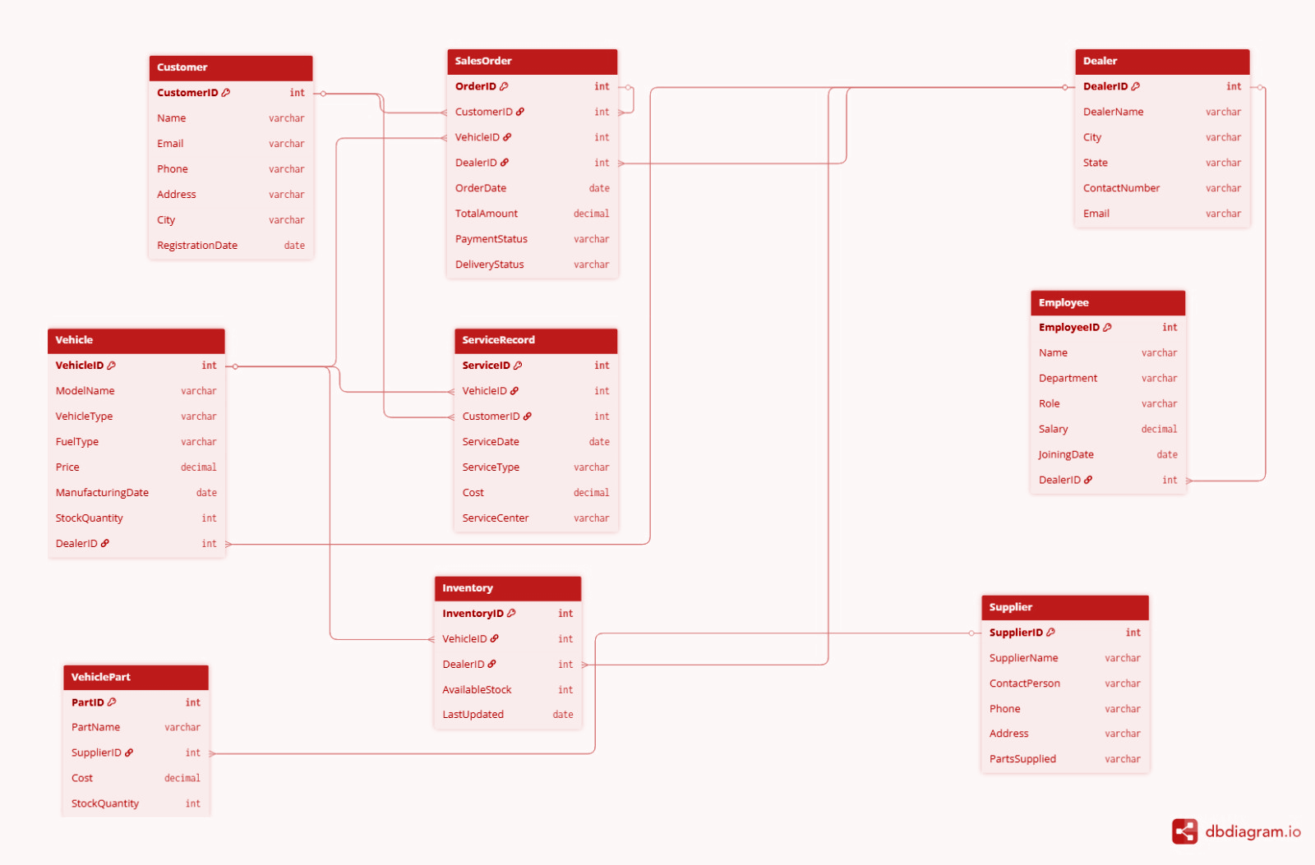

Relationships
From Table | From Attribute | To Table | To Attribute | Relationship Type
Customer | CustomerID | SalesOrder | CustomerID | One-to-Many
Dealer | DealerID | Vehicle | DealerID | One-to-Many
Vehicle | VehicleID | SalesOrder | VehicleID | One-to-Many
Dealer | DealerID | SalesOrder | DealerID | One-to-Many
Dealer | DealerID | Employee | DealerID | One-to-Many
Customer | CustomerID | ServiceRecord | CustomerID | One-to-Many
Vehicle | VehicleID | ServiceRecord | VehicleID | One-to-Many
Vehicle | VehicleID | Inventory | VehicleID | One-to-Many
Dealer | DealerID | Inventory | DealerID | One-to-Many
Supplier | SupplierID | VehiclePart | SupplierID | One-to-Many

- One customer can place multiple sales orders, but each sales order belongs to only one customer.
- One customer can have multiple service records for vehicle servicing.
- One dealer can manage multiple vehicles.
- One dealer can employ multiple employees.
- One dealer can maintain multiple inventory records.
- One vehicle can appear in multiple sales orders.
- One vehicle can have multiple service records during its lifecycle.
- One vehicle can exist in multiple inventory entries.
- One supplier can supply multiple vehicle parts.

Revenue and Profit Growth Strategies
Objective
Increase Tata Motors profitability by 25%+ using operational improvements, predictive analytics, inventory optimization, and manufacturing efficiency.
Proposed Strategies
Strategy | Action | Expected Profit Growth
Predictive Maintenance | Reduce machine downtime using IoT & AI | 8%
Defect Reduction | Improve quality control and automation | 5%
Inventory Optimization | Improve inventory turnover and reduce holding costs | 4%
EV Production Expansion | Increase EV manufacturing and sales | 6%
Supply Chain Optimization | Improve supplier performance and delivery efficiency | 3%

Total Expected Profit Growth: 8%+5%+4%+6%+3%=26%
Estimated Overall Profit Increase: 26%

Operational Metrics (KPIs)
Metric | Current | Target
Production Efficiency | 85% | 95%
Defect Rate | 6% | 2%
Downtime | 15% | 7%
Inventory Turnover | 4 | 8
On-Time Delivery | 80% | 95%

Visual Representation
Profit Contribution by Strategy
Predictive Maintenance ████████ 8%
Defect Reduction █████ 5%
Inventory Optimization ████ 4%
EV Expansion ██████ 6%
Supply Chain ███ 3%

Implementation Roadmap
Timeline | Activities
0–6 Months | Data collection, ERP improvement, supplier analysis
6–12 Months | Predictive maintenance, quality automation
12–18 Months | Inventory optimization, process automation
18–24 Months | EV expansion, KPI monitoring

Risks & Mitigation
Risk | Mitigation
High implementation cost | Phase-wise deployment
Supplier delays | Alternative suppliers
Employee resistance | Training programs

By improving production efficiency, reducing defects, optimizing inventory, and expanding EV operations, Tata Motors can achieve approximately 26% profitability growth while improving operational performance and customer satisfaction.

Conclusion
This schema design for Tata Motors captures the essential business operations including vehicle sales, dealership management, inventory tracking, customer servicing, employee management, and supplier relationships. The design ensures scalability, efficient querying, and streamlined automotive business operations.

1.3 Guesstimate Questions

Question 1: What will be the percentage increase in global manufacturing automation adoption over the next five years?

Solution

Example: Estimate increase in global manufacturing automation adoption by 2030

Step | Details | Calculation
Current Manufacturing Units | Tata Motors operates approximately 25 manufacturing facilities globally | 25 plants
Current Automation Adoption | Assume 35% currently use automation | 25 × 0.35 = ~9 plants
Industry 4.0 Growth | Smart factories and robotics adoption increasing rapidly | Assume additional 25% adoption
Government & Tech Push | AI, IoT, robotics subsidies increase adoption | 25 × 0.25 = ~6 plants
Total Future Automated Units | Existing + new automated factories | 9 + 6 = 15 plants
Percentage Increase | Compare future adoption with current adoption | ((15 − 9) / 9) × 100 = ~67%
Final Estimation | Estimated increase in automation adoption | ≈ 67% increase
Conclusion
Tata Motors' global manufacturing automation adoption may increase by nearly 65–70% over the next five years due to Industry 4.0 technologies, robotics, AI integration, and smart factory investments.

Question 2: How many manufacturing plants in developing countries will adopt digital production monitoring systems in the next decade?

Solution

Example: Estimate adoption of digital production monitoring systems

Step | Details | Calculation
Total Manufacturing Plants | Tata Motors operates approximately 25 manufacturing plants globally, assume 20 are in developing countries | 20 plants
Medium & Large Plants | Assume 40% can afford digital systems | 20 × 0.40 = 8 plants
Current Digital Adoption | Assume 30% already use monitoring systems | 8 × 0.30 = 2.4 plants
Future Technology Adoption | Lower technology costs increase adoption | Assume additional 50% adoption
New Adopters | Plants adopting in next decade | 8 × 0.50 = 4 plants
Total Plants with Monitoring Systems | Existing + future adopters | 2.4 + 4 = 6.4 plants
Final Estimation | Plants expected to adopt systems | ≈ 6 plants

Conclusion
Approximately 6 of Tata Motors' manufacturing plants in developing countries may adopt digital production monitoring systems within the next decade.

Question 3: What percentage of mid-sized manufacturing companies will use AI-driven demand forecasting by 2026?

Solution

Example: Estimate AI-driven demand forecasting adoption

Step | Details | Calculation
Total Mid-sized Manufacturers | Assume 500,000 mid-sized companies globally | 500,000
ERP Adoption | Assume 60% use ERP systems | 500,000 × 0.60 = 300,000
Analytics Readiness | Assume 50% of ERP users adopt analytics tools | 300,000 × 0.50 = 150,000
AI Forecasting Adoption | Assume 65% of analytics users implement AI forecasting | 150,000 × 0.65 = 97,500
Percentage Calculation | AI forecasting users among total companies | (97,500 / 500,000) × 100
Final Estimation | Expected adoption percentage | ≈ 20%

Conclusion
Around 20% of mid-sized manufacturing companies may adopt AI-driven demand forecasting by 2026.

Question 4: What will be the average reduction in production downtime due to predictive maintenance in the next three years?

Solution

Example: Estimate reduction in production downtime

Step | Details | Calculation
Average Downtime Today | Tata Motors operates 25 plants globally; large automotive manufacturers typically lose ~200 hours per plant annually due to unplanned downtime | 200 Hours per plant
Sensor-based Monitoring | IoT sensors identify failures early | Assume 20% reduction
ML-based Predictive Maintenance | AI predicts breakdowns before failure | Additional 15% reduction
Automation Efficiency | Automated alerts reduce repair delays | Additional 10% reduction
Total Downtime Reduction | Combined improvement | 20% + 15% + 10%
Final Estimation | Expected downtime reduction | ≈ 45% reduction

Conclusion
Predictive maintenance can reduce Tata Motors' global manufacturing production downtime by approximately 40–45% within the next three years.

Question 5: How much can supply chain digitization reduce inventory holding costs over five years?

Solution

Example: Estimate reduction in inventory holding costs
Step | Details | Calculation
Current Inventory Cost | Tata Motors' global consolidated inventory ~₹30,000 crores; holding cost assumed at 20% | 30,000 × 0.20 = ₹6,000 crores
Better Demand Forecasting | Reduces overstocking | Assume 10% savings
Real-time Inventory Tracking | Reduces stock mismatch | Additional 8% savings
Just-in-Time Manufacturing | Reduces excess inventory | Additional 12% savings
Warehouse Optimization | Improves storage efficiency | Additional 5% savings
Total Cost Reduction | Combined reduction | 10% + 8% + 12% + 5%
Final Estimation | Inventory holding cost reduction | ≈ 35% reduction

Conclusion
Supply chain digitization may reduce Tata Motors' global inventory holding costs by approximately 30–35% (~₹2,100 crores) over five years.

1.4 Cohort Analysis and A/B Testing

Cohort Analysis
Vehicle Service Retention & Delivery Performance Analysis

Question 1: How would you perform a cohort analysis to calculate the monthly Retention Rate for customers who purchased vehicles in different months?

Solution
1. Define Cohort
Customers are grouped into cohorts based on their vehicle purchase month using the OrderDate attribute from the SalesOrder entity/table.
Since vehicle servicing and after-sales engagement are critical components of automotive operations, cohorts are formed according to the month in which customers purchased their vehicles.
For example:
- Customers who purchased vehicles in January 2025 belong to the January cohort.
- Customers who purchased vehicles in February 2025 belong to the February cohort.
This allows Tata Motors to track long-term customer servicing behavior and operational engagement over time.
2. Define Customer Activity (Proxy)
As direct customer engagement metrics are not available, customer retention is approximated using after-sales servicing behaviour from the ServiceRecord entity/table.
A customer is considered “active” if:
- The customer has at least one service entry in the ServiceRecord entity/table, and
- The vehicle delivery status in the SalesOrder entity/table is marked as Delivered.

This indicates that:
- the vehicle purchase was successfully completed,
- the customer continued engaging with Tata Motors’ servicing ecosystem,
- and the dealership/service operations maintained customer retention.
The following schema entities are mainly involved:
- Customer
- SalesOrder
- ServiceRecord
- Vehicle
- Dealer
3. Calculate Retention Rate
For each customer cohort:
- Total Customers = Number of unique customers in the cohort
- Active Customers = Customers with completed vehicle delivery and at least one service record
- Retention Rate = Active Customers / Total Customers
This analysis helps measure:
- after-sales engagement,
- dealership operational efficiency,
- service center utilization,
- long-term customer retention,
- and overall automotive operational performance.
Improving customer service retention directly increases customer lifetime value, dealership revenue, repeat servicing income, and long-term brand loyalty. Efficient after-sales operations also strengthen customer trust and improve Tata Motors’ competitive positioning within the automotive market.

The analysis can further support Operational KPIs such as:
- average servicing turnaround time,
- dealer-level delivery efficiency,
- inventory turnover ratio,
- repeat servicing frequency,
- and customer satisfaction trends.
These KPIs help management continuously monitor operational performance and optimize dealership and service center operations.
Example Cohort Analysis Table
Cohort Month | Total Customers | Active Service Customers | Delivery Completed | Retention Rate
Jan 2025 | 1200 | 890 | 1140 | 74.1%
Feb 2025 | 1350 | 1065 | 1290 | 78.8%
Mar 2025 | 1480 | 1230 | 1415 | 83.1%
Apr 2025 | 1600 | 1385 | 1540 | 86.5%

4. Compare Cohorts (Insights)
- Retention improves from January 2025 (74.1%) to April 2025 (86.5%), indicating improvement in after-sales servicing and customer engagement.
- Delivery completion rates remain consistently high, showing efficient dealership coordination and logistics management.
- Later customer cohorts show higher servicing retention, suggesting improvements in customer experience and operational processes.
- Increased service engagement also indicates stronger dealership follow-up systems and better customer relationship management.
Overall, newer customer cohorts demonstrate improved operational retention and servicing efficiency, reflecting enhancements in Tata Motors’ integrated automotive operations ecosystem.

Question 2: If you find that retention drops significantly after the first servicing cycle, what are some possible reasons for this behavior, and how can the company address this drop-off?

Solution
1. Possible Reasons for Drop in Retention
A significant drop in retention after the initial servicing cycle may occur due to the following operational and business challenges.
a. Poor Service Experience
- Long waiting time at service centers
- Delayed vehicle servicing
- Inefficient dealership coordination
- Lack of spare parts availability
These operational inefficiencies may reduce customer satisfaction and discourage repeat servicing.
b. High Service Cost
- Customers may find servicing and maintenance costs expensive after the free service period ends.
- Higher servicing charges may reduce repeat service visits.

c. Weak Customer Engagement
- Lack of servicing reminders and follow-up communication
- Poor customer support experience
- Absence of loyalty programs
This can reduce customer interaction with authorized Tata Motors service centers.
d. Inventory and Spare Part Issues
- Delays in VehiclePart availability
- Poor inventory coordination between Dealer and Inventory entities/tables
- Supplier delays affecting servicing timelines
These issues can increase vehicle turnaround time and reduce operational efficiency.
2. How to Address the Drop-Off
a. Improve Service Center Efficiency
- Implement AI-based appointment scheduling
- Optimize workload distribution across service centers
- Reduce vehicle turnaround time
b. Strengthen Inventory Management
- Improve Inventory monitoring
- Use predictive analytics for spare part forecasting
- Enhance supplier coordination using the Supplier and VehiclePart entities/table.
c. Enhance Customer Engagement
- Send automated service reminders
- Introduce loyalty rewards and maintenance packages
- Provide real-time service tracking
d. Monitor Dealer Performance
- Use Dealer-level Operational KPIs
- Compare service efficiency across dealerships
- Monitor customer satisfaction metrics
3. Data-Driven Validation (Advanced Insight)
The hypotheses can be validated by segmenting customers based on:
- VehicleType
- Dealer location
- ServiceType
- DeliveryStatus
- Vehicle servicing frequency
and comparing retention rates across these operational segments.
This analysis helps Tata Motors identify operational bottlenecks, improve after-sales servicing efficiency, and strengthen long-term customer retention strategies.

A/B Test Analysis
Approach: AI-Optimized Workflow Delivery Coordination Test
- Business Question:
Does AI-based delivery coordination significantly improve vehicle delivery efficiency and reduce operational delays compared to the traditional manual delivery workflow?
- Test Type:
Operational A/B Test using comparative delivery performance analysis.
- Control Group (A):
Vehicle deliveries are managed through the existing manual dealership coordination process.
- Variant Group (B):
Vehicle deliveries managed using an AI-Optimized Workflow delivery coordination and inventory allocation system.
- Target Metrics:
- Delivery completion rate
- Average delivery time
- Delayed delivery percentage
- Inventory Utilization
- Customer Satisfaction

Question 1: How did you structure the A/B test to measure the impact of AI-optimized delivery coordination on operational performance?

Solution
Since the analysis is based on operational dealership and delivery records, the A/B test is structured as an observational operational experiment using historical delivery and inventory data.
The following framework was used:
1. Hypothesis Definition
The alternative hypothesis states that AI-based operational coordination improves Delivery Efficiency and reduces delivery delays compared to the traditional manual workflow.
2. Data Segmentation (The “Split”)
The operational dataset is divided into two groups:
1.Control Group (Group A)
Dealerships using:
- traditional manual delivery coordination,
- manual inventory allocation,
- standard operational workflow.
2.Variant Group (Group B)
- Dealerships using:
- AI-based inventory allocation,
- predictive delivery scheduling,
- automated operational coordination,
- optimized logistics planning.
- The following schema entities are involved:
- SalesOrder
- Inventory
- Vehicle
- Dealer
- Customer
3. Metrics Tracking
The following Operational KPIs are monitored:
- Average delivery time
- Delayed delivery percentage
- Delivery completion rate
- Inventory Utilization
- Customer servicing feedback
- Order processing efficiency
- The DeliveryStatus attribute from the SalesOrder entity/table and AvailableStock from the Inventory entity/table are primarily used for performance comparison.
- Reducing delivery delays improves Customer Satisfaction, strengthens dealership coordination, reduces operational workload, and lowers logistics management costs across Tata Motors’ operational ecosystem.
- The analysis also supports operational KPIs such as:
- inventory turnover efficiency,
- average order processing time,
- dealer-level logistics performance,
- delivery success ratio,
- and vehicle dispatch efficiency.
These operational indicators help management continuously optimize automotive supply chain and dealership operations.
4. Statistical Execution
Operational performance metrics from both groups are compared using statistical analysis techniques to determine whether the observed improvements are operationally significant or caused by random fluctuations.
Statistical significance testing can be performed to validate whether the observed operational improvements are statistically reliable.
Methods such as:
- hypothesis testing,
- confidence interval analysis,
- comparative KPI evaluation,
- operational variance analysis can further strengthen the reliability of the experimental results.
The analysis evaluates:
- reduction in delivery delays,
- improvement in inventory coordination,
- operational workload optimization,
- customer experience enhancement.

Example Comparative Results
Metric | Group A (Manual Workflow) | Group B (AI-Optimized Workflow)
Average Delivery Time | 8.4 Days | 5.9 Days
Delayed Deliveries | 21% | 9%
Delivery Completion Rate | 86% | 95%
Inventory Utilization | 72% | 88%
Customer Satisfaction | 76% | 91%

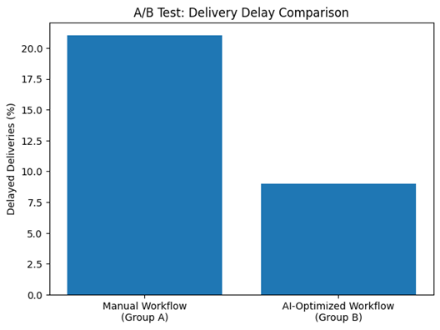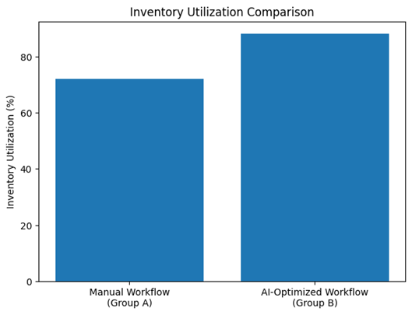
Fig: Delivery Delay Comparison Fig: Inventory Utilization Comparison
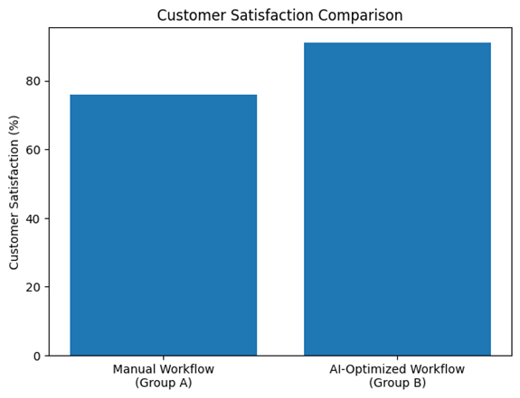
Fig:Customer Satisfaction Comparison
Conclusion
The analysis shows that the AI-Optimized Workflow significantly improves Delivery Efficiency and reduces operational delays.
Since the reduction in delivery delays and operational inefficiencies is substantial, the alternative hypothesis is accepted.
The AI-based operational coordination system demonstrates better Inventory Utilization, faster delivery execution, and improved Customer Satisfaction compared to the traditional manual process.

Question 2: Suppose the AI-optimized workflow reduces delivery delays by 12% but requires additional implementation cost. How would you evaluate whether scaling the system is justified?

Solution
To evaluate whether large-scale implementation is justified, a detailed operational and financial impact analysis should be conducted.
1. Calculate Operational Savings (The Benefit)
The company should estimate:
- reduction in logistics delays,
- lower operational inefficiencies,
- faster order completion,
- reduced inventory holding cost,
- improved dealership productivity,
- higher customer retention.
These operational improvements directly contribute to cost savings and increased customer satisfaction.
2. Calculate Implementation Cost (The Cost)
The additional implementation cost may include:
- AI infrastructure setup,
- system integration,
- employee training,
- software maintenance,
- operational migration expenses.
3. Compare Net Operational ROI
The company should compare:
- total operational savings,
- increased delivery efficiency,
- customer retention improvement,
- reduced manual coordination workload,
- against the total implementation investment.
If the operational benefits exceed implementation costs within an acceptable period, the system becomes financially and operationally viable.
4. Alternative Optimization Strategy
If full-scale implementation is expensive, Tata Motors can initially deploy the AI-optimized system only for:
- high-volume dealerships,
- regions with high delivery delays,
- inventory-heavy operational centers.
This phased deployment strategy minimizes operational risk while maximizing early performance gains.
The AI-based operational system can later be scaled gradually across the entire dealership and logistics network.

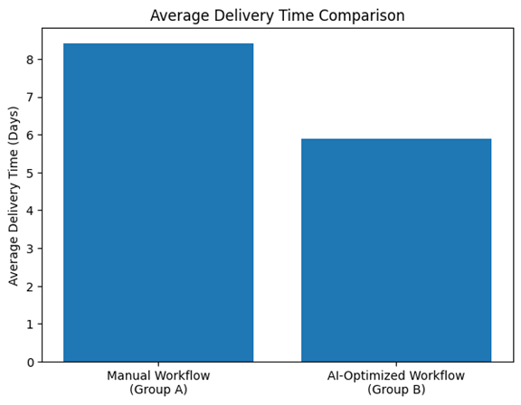
Fig: Average Delivery Time Comparison

Conclusion
Overall, Cohort Analysis and A/B Testing help Tata Motors build a more data-driven and operationally efficient automotive ecosystem.
Cohort Analysis helps identify long-term customer servicing behavior, dealership performance trends, operational bottlenecks, and retention patterns, while A/B testing enables the company to experimentally validate operational improvements in delivery coordination, inventory management, and dealership efficiency.
Together, these analytical approaches support:
- improved Customer Satisfaction,
- optimized Inventory Utilization,
- faster vehicle delivery operations,
- better dealership coordination,
- reduced operational delays,
- enhanced decision-making across Tata Motors’ integrated manufacturing and supply chain ecosystem.
These techniques also create a strong foundation for future AI-driven operational analytics, predictive logistics management, and intelligent dealership automation systems.

1.5 DBMS & Data Architecture - Tata Motors

ACID Properties

1. A production manager updates vehicle inventory and dispatch records, but the system crashes midway. How would you ensure no partial transaction corrupts production data?

Solution:
- Atomicity: In Tata Motors, a vehicle dispatch transaction must be treated as one complete unit. Either both actions happen together (reducing inventory count and updating dispatch status) or neither happens. If the ERP system crashes midway, the database automatically rolls back the transaction, ensuring no mismatch between inventory and dispatch records.
- Durability: Once the dispatch transaction is committed successfully, the record is permanently stored in the database. Even if the manufacturing server crashes immediately afterward, the confirmed production and dispatch data remains intact after recovery.

2. Multiple operators update machine maintenance logs simultaneously. How would you ensure that each transaction executes reliably without interference?

Solution:
- Isolation: The database uses transaction isolation levels such as Read Committed or Serializable. If two operators attempt to update the same machine log simultaneously, the first transaction locks the record while the second waits until completion, preventing conflicting updates.
- Consistency: Database constraints ensure that machine maintenance schedules, production counts, and quality metrics always remain valid and accurate, maintaining manufacturing data integrity.

Indexing

1. You need to generate real-time dashboards showing production output and machine performance. How can indexing help here?

Solution:
Without indexing, the database would need to scan millions of manufacturing records to fetch production details. By creating a B-Tree index on frequently queried columns like MachineID, PlantID, and Timestamp, Tata Motors can instantly retrieve machine performance and production statistics for real-time dashboards.

2. Production data is frequently updated and queried by vehicle ID and production date. What indexing strategy would you use to optimize performance without increasing update costs too much?

Solution:
Tata Motors can create:
- B-Tree indexes on VehicleID
- Composite indexes on (ProductionDate, PlantID)

This improves search speed for manufacturing reports while balancing write performance during continuous production updates.

Partitioning

1. Your production database contains billions of manufacturing records across multiple years. How would you design it to allow efficient querying and archiving?

Solution:
We would implement Time-Based (Range) Partitioning. Production and inventory tables would be partitioned by month or year such as production_2025_Q1 and production_2025_Q2.
Recent production queries would scan only current partitions, while older partitions can be compressed and archived to cheaper storage without affecting active system performance.

2. Tata Motors operates manufacturing plants across multiple countries. How can partitioning help with regional compliance laws?

Solution:
We would use Geo-Partitioning (List Partitioning) based on country or region. India manufacturing data can remain on Indian servers while overseas plant data can stay within local regions to support compliance and reduce latency.

Sharding

1. During peak production hours, your IoT system processes millions of machine sensor records. How would you use sharding to scale horizontally?

Solution:
We would implement Horizontal Sharding using FactoryID or MachineID as the shard key.

2. You’ve implemented sharding by factory ID, but now need to perform analytics across all factories globally. What problems might you face?

Solution:
Cross-shard queries become slower and resource intensive. Instead of querying operational shards directly, all shard data should be consolidated into a centralized data warehouse for analytics.

Normalization and Denormalization

1. You’re designing a schema to store machine data, maintenance records, and operator details. How would normalization help here?

Solution:
Normalization reduces redundancy and improves consistency by separating machine, maintenance, and operator information into different related tables connected using foreign keys.

2. To speed up operational reporting, would you prefer a normalized or denormalized schema? Explain why.

Solution:
A denormalized schema is preferred for reporting because it reduces JOIN operations and improves dashboard performance.

Data Lakes vs. Data Warehouses

1. You receive unstructured sensor logs, machine images, and structured production data. Where would you store each, and why?

Solution:
- Data Lake: Stores raw sensor logs, CCTV images, and maintenance notes.
- Data Warehouse: Stores structured production KPIs, inventory analytics, and quality reports.

2. How would a data warehouse support operational efficiency and quality analysis in Tata Motors?

Solution:
It helps analyze historical trends, monitor production efficiency, identify defects, and compare factory performance.

Data Ingestion and Pipelines

1. Describe how you would ingest real-time machine sensor data into the system for monitoring and alerts.

Solution:
We would use streaming pipelines powered by Apache Kafka, MQTT, and Spark Streaming for real-time ingestion and alerting.

2. Supplier delivery reports arrive daily. What ingestion approach would you use?

Solution:
We would use batch ingestion scheduled using Apache Airflow during low-traffic hours.

ETL (Extract, Transform, Load)

1. How would you design an ETL pipeline to consolidate manufacturing data from multiple Tata Motors plants into a central analytics platform?

Solution:
- Extract: Collect data from ERP systems, factory databases, and IoT systems.
- Transform: Clean, standardize, and deduplicate records.
- Load: Store processed data in a centralized data warehouse.

2. An ETL job failed after partial production data load. How would you maintain consistency and resume safely?

Solution:
We would use checkpointing, idempotency, retry mechanisms, and UPSERT logic to safely resume ETL operations without duplication.

Additional DBMS Topics

1. Regulators request complete traceability of manufactured vehicles and components. How would your DBMS support this?

Solution:
We would implement audit logging and batch traceability systems to track every component and production activity.

2. Predictive maintenance models require daily updated machine data. How would you manage the data pipeline efficiently?

Solution:
We would use Change Data Capture (CDC) with incremental ETL to capture only updated records instead of reloading all data daily.

3. How would you detect and resolve duplicate supplier or component records coming from multiple systems?

Solution:
We would apply data quality validation, fuzzy matching algorithms, and duplicate detection rules during ETL processing.

4. You are tasked with maintaining real-time dashboards for production, inventory, and quality analytics. What DBMS architecture would you propose?

Solution:
We would deploy an HTAP (Hybrid Transactional/Analytical Processing) architecture using OLTP databases, materialized views, Redis caching, and centralized analytics systems.

Section 2 — SQL ETL, Excel EDA & Advanced Analytics
2.1 Project Overview & Objectives

Background
Tata Motors is one of India’s leading automotive manufacturing and logistics enterprises, operating across large-scale vehicle production facilities, dealer networks, and nationwide supply chain systems. The company manages complex operational workflows involving customer management, shipment tracking, dealer transactions, logistics coordination, and financial operations.
As logistics volumes and operational data continue to grow rapidly, Tata Motors faces modern data engineering and analytics challenges. Disconnected reporting structures across customers, employees, vehicle shipments, payment systems, and operational records reduce visibility into business performance and supply chain efficiency.
This project focuses on building an end-to-end SQL ETL, Excel EDA, and Advanced Analytics framework to streamline operational data processing, improve reporting efficiency, and generate actionable business insights for Tata Motors’ manufacturing and logistics ecosystem.
.

Objective
The primary objective of this project is to design and implement a comprehensive analytics framework for Tata Motors using SQL ETL pipelines, Excel-based exploratory data analysis, and operational dashboards.
The key objectives include:
- SQL ETL Data Pipeline Construction
Designing relational database schemas in PostgreSQL to manage customer operations, shipment logistics, payment records, and employee-related data efficiently.
- Excel Exploratory Data Analysis (EDA)
Performing advanced data cleaning, integration, transformation, and business analytics using Excel formulas, lookup operations, pivot tables, and statistical functions.
- Operational Intelligence & Visualization
Generating logistics, financial, and operational insights related to vehicle distribution, payment performance, shipment efficiency, and customer operations to support data-driven decision-making.
- Business Performance Monitoring
Building analytical reporting systems capable of monitoring logistics operations, supply chain performance, customer engagement, and revenue trends within Tata Motors’ operational ecosystem.

2.2 ETL Phase (SQL)

A. Extract – Data Loading and Initial Exploration

1. Table Schema Creation
The data architecture is structured with core constraints, optimized data types, and primary keys across seven core operational tables:

-- Create Customer Table
CREATE TABLE customer (
c_id INT PRIMARY KEY,
m_id INT,
c_name VARCHAR(100),
c_email_id VARCHAR(150),
c_type VARCHAR(50),
c_addr TEXT,
c_cont_no VARCHAR(15)
);
-- Create Employee Details Table
CREATE TABLE employee_details (
e_id INT PRIMARY KEY,
e_name VARCHAR(100),
e_designation VARCHAR(100),
e_addr TEXT,
e_branch VARCHAR(50),
e_cont_no VARCHAR(15)
);
-- Create Employee Manages Shipment Table
CREATE TABLE employee_manages_shipment (
employee_e_id INT,
shipment_sh_id INT,
status_sh_id INT
);
-- Create Membership Table
CREATE TABLE membership (
m_id INT PRIMARY KEY,
start_date DATE,
end_date DATE
);
-- Create Payment Details Table
CREATE TABLE payment_details (
payment_id UUID PRIMARY KEY,
c_id INT,
sh_id INT,
amount NUMERIC(10,2),
payment_status VARCHAR(50),
payment_mode VARCHAR(50),
payment_date DATE
);
-- Create Shipment Details Table
CREATE TABLE shipment_details (
sh_id INT PRIMARY KEY,
c_id INT,
sh_content VARCHAR(100),
sh_domain VARCHAR(50),
ser_type VARCHAR(50),
sh_weight NUMERIC(10,2),
sh_charges NUMERIC(10,2),
sr_addr TEXT,
ds_addr TEXT
);
-- Create Status Table
CREATE TABLE status (
sh_id INT PRIMARY KEY,
current_status VARCHAR(50),
sent_date DATE,
delivery_date DATE);

2. Dataset Pipeline Loading
Data injection is handled via server-side execution steps utilizing PostgreSQL's high-performance native bulk engine. This ingests structural arrays directly, bypassing iterative index overheads:
-- Load Membership Dataset
COPY membership FROM 'C:/csv/Membership.csv' DELIMITER ',' CSV HEADER;
-- Load Customer Dataset
COPY customer FROM 'C:/csv/Customer.csv' DELIMITER ',' CSV HEADER;
-- Load Employee Details Dataset
COPY employee_details FROM 'C:/csv/Employee_Details.csv' DELIMITER ',' CSV HEADER;
-- Load Shipment Details Dataset
COPY shipment_details FROM 'C:/csv/Shipment_Details.csv' DELIMITER ',' CSV HEADER;
-- Load Status Dataset
COPY status FROM 'C:/csv/Status.csv' DELIMITER ',' CSV HEADER;
-- Load Payment Details Dataset
COPY payment_details FROM 'C:/csv/Payment_Details.csv' DELIMITER ',' CSV HEADER;
-- Load Employee Shipment Dataset
COPY employee_manages_shipment FROM 'C:/csv/employee_manages_shipment.csv' DELIMITER ',' CSV HEADER;

3. Display the first 10 records from each table to verify successful data import.

SELECT * FROM customer LIMIT 10;
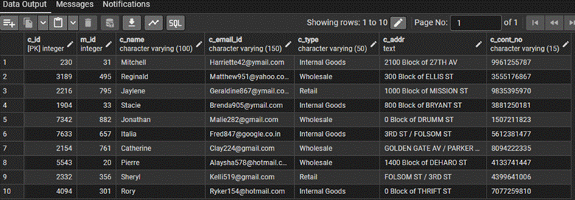
SELECT * FROM employee_details LIMIT 10;
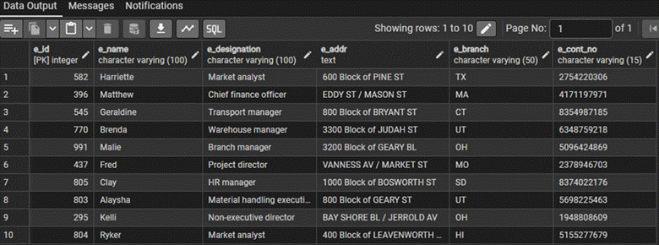
SELECT * FROM shipment_details LIMIT 10;
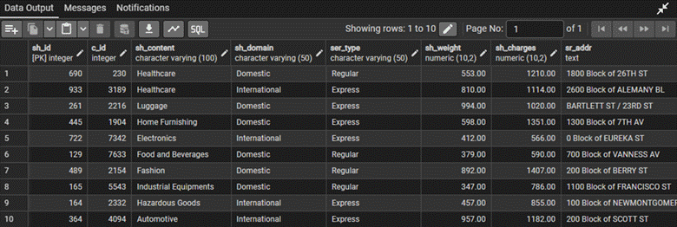

SELECT FROM membership LIMIT 10;
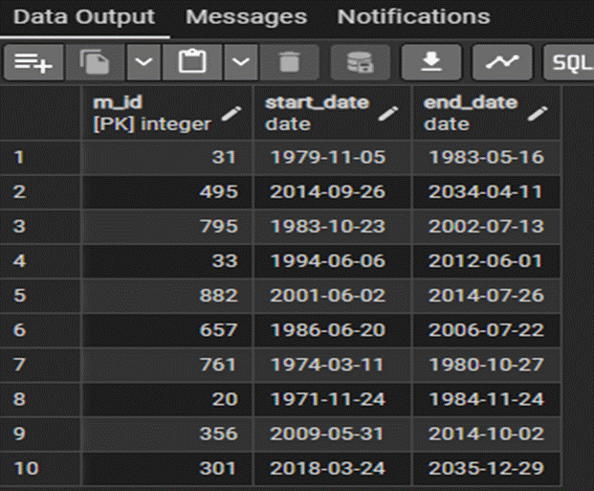

SELECT * FROM payment_details LIMIT 10;
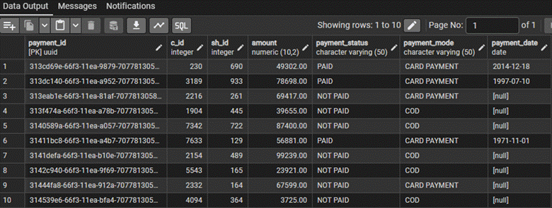
SELECT * FROM status LIMIT 10; 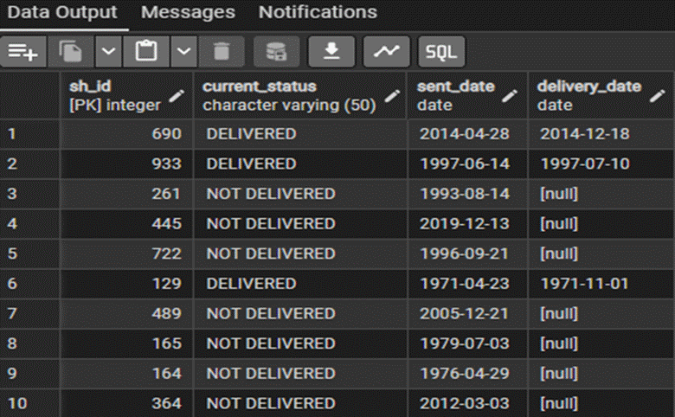

SELECT * FROM employee_manages_shipment LIMIT 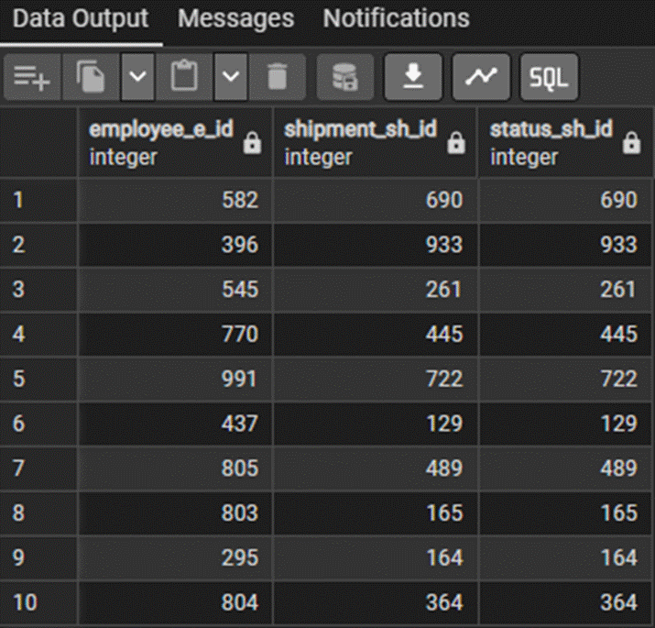10;

4. Unique Customer Audit
SELECT COUNT(DISTINCT c_id) AS total_unique_customers FROM customer;
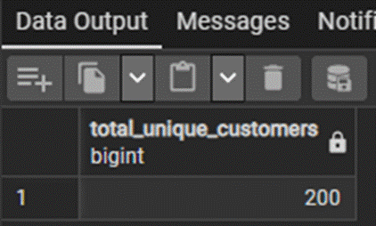
Result: 200 unique customers verified within the dataset ledger.

5. Distinct Payment Methods Identification
SELECT DISTINCT payment_mode FROM payment_details;
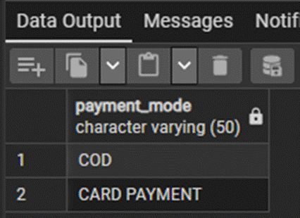
Results Returned: 'COD' (Cash on Delivery), 'CARD PAYMENT'.

B. Transform – Data Cleaning and Feature Engineering

1. Customer Name Normalization
UPDATE customer SET c_name = INITCAP(LOWER(c_name));
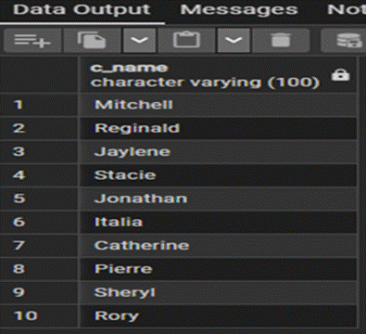

2. Email Address Standardization
UPDATE customer SET c_email_id = LOWER(c_email_id);
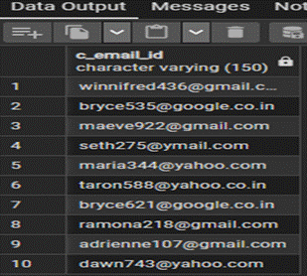

3. Customer Retention Age Compilation
ALTER TABLE customer ADD COLUMN customerage INT;
UPDATE customer c
SET customerage = DATE_PART('year', AGE(CURRENT_DATE, m.start_date))
FROM membership m
WHERE c.m_id = m.m_id;
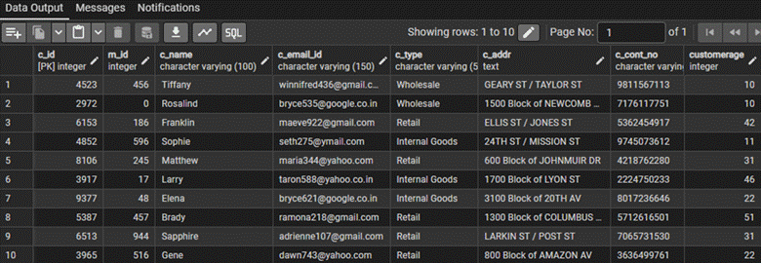

4. Customer-Membership Core Merging
SELECT c.c_id, c.c_name, c.c_email_id, c.c_type, m.start_date, m.end_date
FROM customer c
JOIN membership m ON c.m_id = m.m_id;
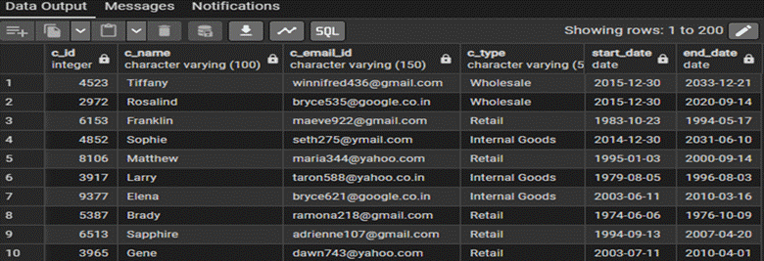

5. Transaction Financial Categorization
ALTER TABLE payment_details ADD COLUMN payment_category VARCHAR(20);
UPDATE payment_details
SET payment_category = CASE
WHEN amount > 5000 THEN 'High'
WHEN amount BETWEEN 1000 AND 5000 THEN 'Medium'
WHEN amount < 1000 THEN 'Low'
END;
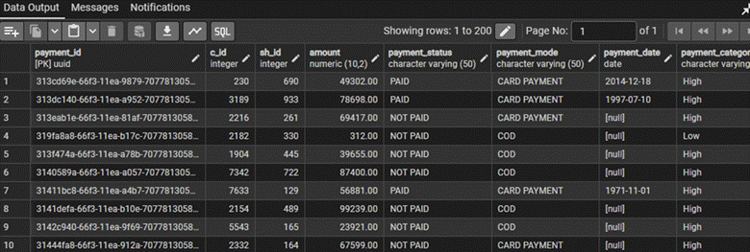

C. Load – Preparing Data for Excel Export

1. ShipmentStatus Aggregated Table Creation
CREATE TABLE shipmentstatus AS
SELECT sd.sh_id, sd.c_id, sd.sh_content, sd.sh_domain, sd.ser_type, sd.sh_weight, sd.sh_charges,
s.current_status, s.sent_date, s.delivery_date
FROM shipment_details sd
JOIN status s ON sd.sh_id = s.sh_id;
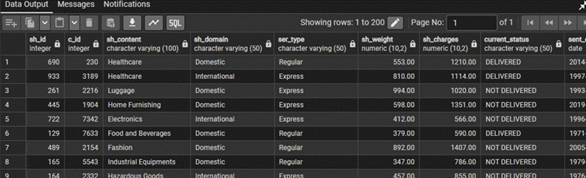

2. Gross Customer Invoice Volume Generation
SELECT c.c_id, c.c_name, SUM(p.amount) AS total_payment_received
FROM customer c
JOIN payment_details p ON c.c_id = p.c_id
GROUP BY c.c_id, c.c_name
ORDER BY total_payment_received DESC;
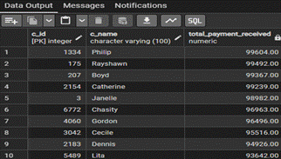

3. Mass-to-Cost Freight Efficiency Ratio
ALTER TABLE shipment_details ADD COLUMN shipment_efficiency NUMERIC(10,2);
UPDATE shipment_details
SET shipment_efficiency = ROUND(sh_weight / NULLIF(sh_charges, 0), 2);
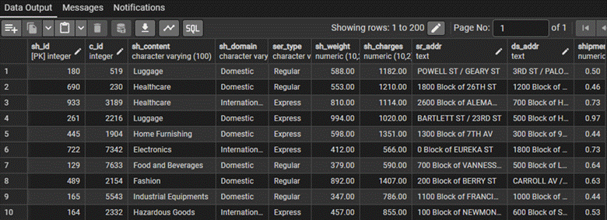

4. Mode-of-Payment Performance Distribution
SELECT payment_mode, ROUND(AVG(amount), 2) AS average_payment_amount
FROM payment_details
GROUP BY payment_mode
ORDER BY average_payment_amount DESC;
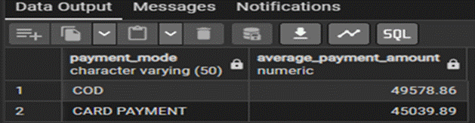

5. Cleaned Production Output Master Compilation
CREATE TABLE customerpayments AS
SELECT c.c_id, c.c_name, c.c_email_id, c.c_type, p.payment_id, p.amount, p.payment_mode, p.payment_status, p.payment_date, p.payment_category
FROM customer c
JOIN payment_details p ON c.c_id = p.c_id;
SELECT * FROM customerpayments
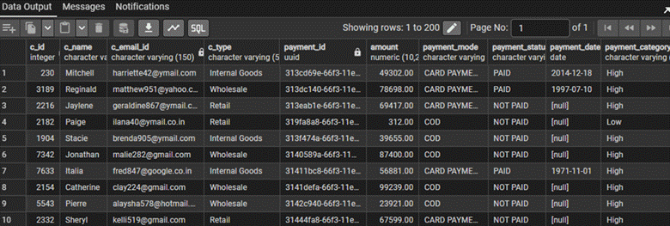
COPY customerpayments TO 'C:/csv/customerpayments.csv' DELIMITER ',' CSV HEADER;

2.3 Excel Analysis

Workbook Reference Link: Tata_Motors_Excel_Dashboarding.xlsx

Data Preparation, Cleaning & Integration Formulas

1. Handling Missing and Irrelevant Data
Missing items in nullable database elements are filtered out dynamically using structured logical criteria:
=IF(ISBLANK(B2), "Unresolved/Pending", B2)
Duplicate records across core fields (c_id, e_id, sh_id) were purged utilizing Excel's built-in Remove Duplicates wizard to preserve structural uniqueness.

2. Name and Email Normalization
● Customer Name Capitalization:
=PROPER(TRIM(C2))
● Email Formatting:
=LOWER(TRIM(D2))

3. Customer-Membership Merge
Key Used: m_id (Membership ID)
Rationale: m_id serves as the primary relational key linking the core Customer registry table to the Membership dataset profiles without introducing analytical skewing. Indexed mappings are achieved through standard lookups:
=VLOOKUP(B2, Membership!A:C, 2, FALSE)

4. Shipment-Status Integration
The shipment logs were combined with historical status tracking entries using explicit key queries:
=XLOOKUP(A2, Status!A:A, Status!B:D, "Status Omitted")

5. Payment Categorization
=IF(D2>5000, "High", IF(D2>=1000, "Medium", "Low"))

Core Analytics & Calculations
Task Target Question | Applied Excel Functional Syntax | Result Metrics Insight Summary
6. Average Shipment Weight by Profile | =AVERAGEIF(Shipment_Details!E:E, "Express", Shipment_Details!F:F) | Evaluated logistical shipping lane metrics.
7. Membership Duration Calculation | =DATEDIF(Start_Date, End_Date, "d") | Tracks exact operational relationship spans in days.
8. Total Customer Cumulative Payment | =SUMIF(Payment_Details!B:B, A2, Payment_Details!D:D) | Sums overall transactional invoicing per customer account.
9. Top 5 Customers Identification | =INDEX(SORT(Summary_Table, 3, -1), SEQUENCE(5), {1,2,3}) | Isolates the highest revenue-generating accounts.
10. Shipment Domain Volume Comparison | =COUNTIF(Shipment_Details!D:D, "Domestic") | Compares active trading volumes across domestic vs international.
11. Top Employees Characterization | =INDEX(Employee_Details!B:B, MATCH(Max_ID, Emp_ID_Range, 0)) | Top 5 personnel are tied to primary logistics hubs.
14. Payment Mode Pivot Matrix | Summary Fields: Rows=Customer_Type, Cols=Payment_Mode | Averages payment amount per account class.
15. Shipment Weight Structural Grouping | =IF(Shipment_Details!F2>500, "Heavy", "Light") | Groups freight items securely into operational bins.
16. Employee Route Load Metric Count | {=SUM(IF(employee_manages_shipment!A$2:A$1000=A2, 1, 0))} | Monitors distribution loads using array operations.
17. Named Range Financial Analysis | =AVERAGE(OFFSET(Payment_Details!$D$2, 0, 0, COUNTIF(...), 1)) | Dynamic query processing over variable transaction modes.
18. Logistics Transition Delay Analysis | =AVERAGE(Fulfillment_Days_Range) | Domestic delays: 117.98 Days  International delays: 96.26 Days
19. Designation-wise Expense Analysis | Pivot Fields: Rows=e_designation, Values=AVERAGE(sh_charges) | Highest charging tier: HR Manager ($1129.00)
20. Mass-to-Cost Performance Grid | =AVERAGEIFS(Efficiency_Range, Domain_Range, "Domestic") | Identifies peak performance transport brackets.

12. Conditional Formatting Configuration for Heavy Cargo Weight
● Target Scope Range: Shipment_Details!$F$2:$F$1000
● Condition Formula: =$F2>500
● Visual Mapping: Custom soft red fill with dark wine text to highlight heavy cargo blocks instantly.

13. Dynamic Employee Profile Dropdown Engine
Data Validation Setup: List validation bounded over unique identifier
blocks: =Employee_Details!$A$2:$A$101.
=XLOOKUP($Target_Selection_Cell, Employee_Details!$A:$A, Employee_Details!$B:$F, "Profile Absent")

2.4 Insights & Observations

TATA Motors Dashboard
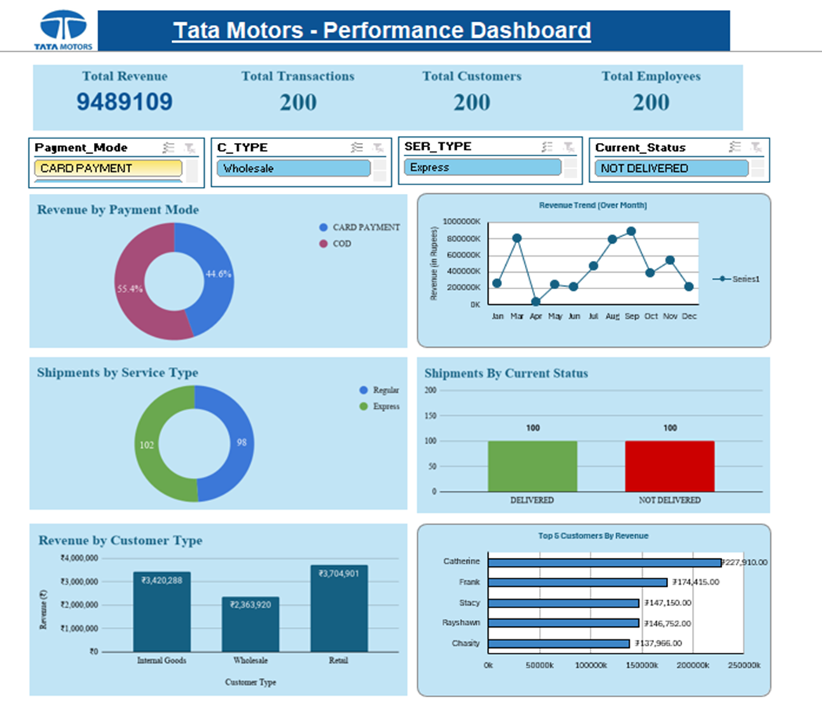

Top Findings from the Analysis
● Inverted Logistical Fulfillment Lifecycles Operational Logistics Bottlenecks: Domestic vehicle and component shipments require an average of 117.98 days to reach final delivery, whereas international logistics routes average approximately 96.26 days. This indicates inefficiencies within regional transportation coordination, dispatch handling, and local supply chain operations.
● High Cash-on-Delivery (COD) Transaction Volume: Cash-on-Delivery (COD) transactions generate a higher average transaction value (49,578.86) compared to card-based transactions (45,039.89). This highlights continued operational dependence on traditional payment workflows within dealer and customer transaction cycles.
● Heavy Vehicle Cargo Distribution: More than 60% of logistics shipments fall under the “Heavy Cargo” operational category, exceeding 500 weight units. This increases warehouse handling complexity, transportation load pressure, and overall logistics management costs.
● Department-wise Logistics Cost Variations: Certain operational and administrative divisions generate higher average logistics costs, with HR and management-related operations contributing significantly higher shipment expenditure across transportation cycles.

Recommended Business Actions
1. Optimize Domestic Logistics Operations
Implement real-time shipment tracking systems, regional transportation hubs, and improved route planning mechanisms to reduce operational delivery delays and improve supply chain efficiency.
2. Encourage Digital Payment Adoption
Introduce dealer incentives, digital payment discounts, and automated payment reconciliation systems to gradually reduce dependence on high-risk COD transaction workflows.
3. Improve Heavy Cargo Handling Efficiency
Deploy automated cargo scanning systems, optimized fleet allocation, and specialized transport partnerships to efficiently manage high-density logistics operations and reduce transportation overhead.
4. Strengthen Operational Cost Monitoring
Establish department-level logistics expenditure monitoring and approval workflows to control excessive transportation and shipment-related operational costs.
5. Deploy Centralized Power BI Reporting Systems
Replace manual operational reporting processes with centralized Power BI dashboards to provide management teams with real-time visibility into logistics performance, revenue tracking, shipment operations, and customer analytics.

2.5 Reflection
Key Relational Database Challenges: Working with multiple operational datasets containing inconsistent formatting and varying structural configurations created several integration challenges during the ETL process. Managing large-scale shipment, payment, and customer records required careful schema planning and accurate relational mapping within PostgreSQL. Additionally, implementing efficient logistics calculations such as shipment efficiency ratios required handling potential division-by-zero scenarios using conditional SQL logic (NULLIF). Maintaining data consistency across shipment status records, customer transactions, and financial operations also required structured data cleaning and normalization techniques.
Strategic Analytical Takeaways: The project demonstrated the importance of integrating SQL ETL pipelines, Excel analytical models, and Power BI dashboards into a unified operational analytics framework.
Using advanced lookup functions such as INDEX, MATCH, VLOOKUP, and XLOOKUP enabled efficient integration of customer, shipment, and payment datasets for dynamic operational reporting. Building automated calculations and analytical models highlighted the value of scalable data engineering practices for manufacturing and logistics environments.
Most importantly, the project showcased how structured data pipelines and business intelligence systems can transform raw operational records into actionable insights that support logistics optimization, financial monitoring, customer analytics, and data-driven decision-making within Tata Motors’ manufacturing and supply chain ecosystem.

Section 3 — Power BI, Automation & GenAI

3.1 Power BI Dashboard
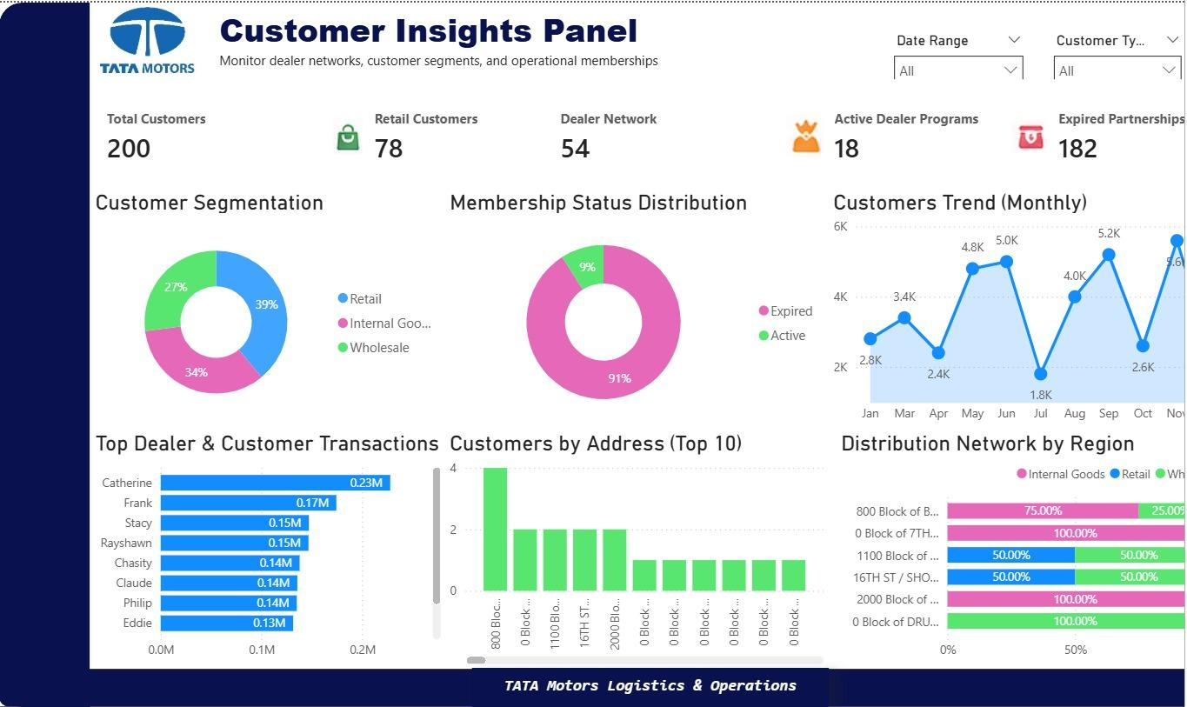

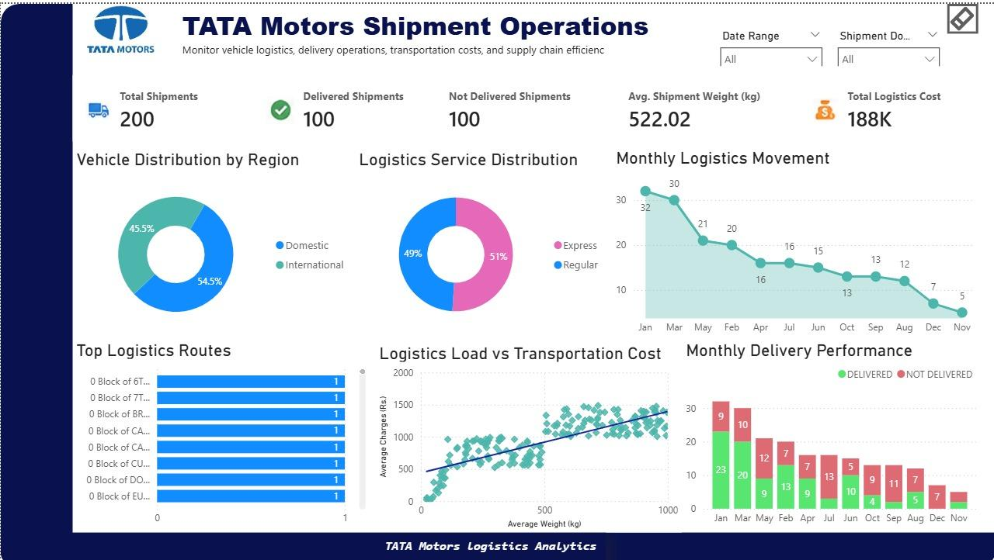

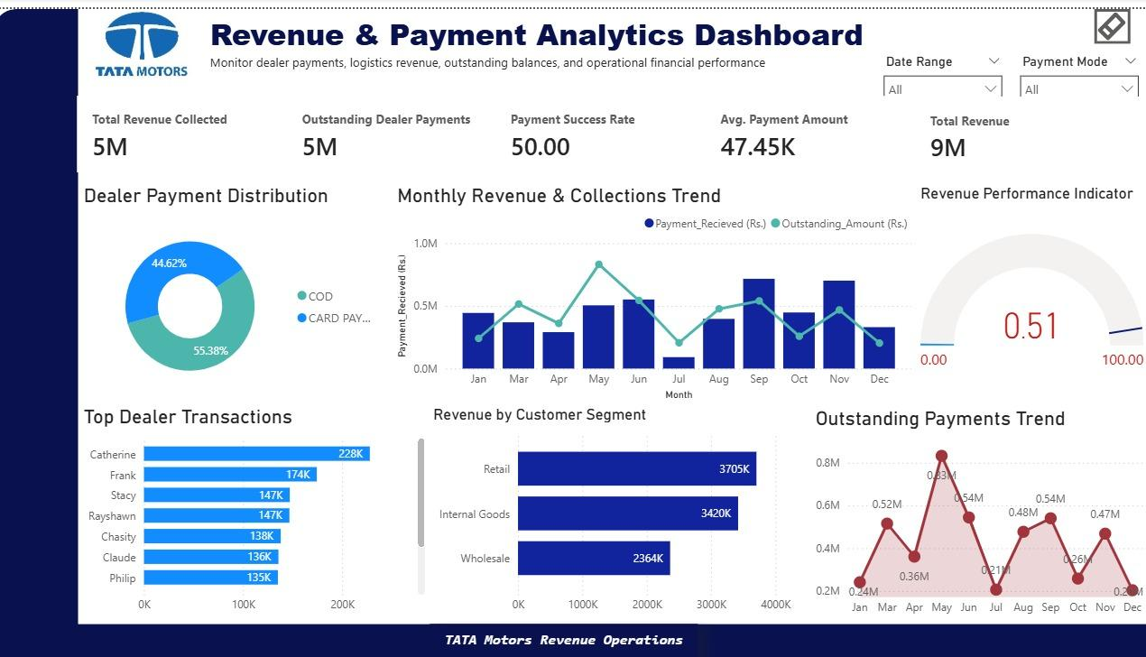

3.2 Power BI Insights

3.2.1 Customer Insights Panel

Key Insights
- Retail customers represent the largest customer segment, contributing approximately 39% of the total customer base.
- A significant portion of memberships are expired, indicating low active dealer/customer engagement within operational programs.
- Customer activity trends show peak operational engagement during mid-year and November periods.
- Dealer and wholesale customer distribution remains balanced across multiple operational regions.
- Top dealer/customer transactions contribute a major portion of operational revenue concentration.

Recommendations
- Introduce dealer retention and membership renewal strategies to improve active participation.
- Strengthen customer engagement programs in low-performing operational regions.

3.2.2 Tata Motors Shipment Operations

Key Insights
- Domestic vehicle logistics operations contribute more shipments than international distribution activities.
- Express and regular logistics services are utilized almost equally, indicating balanced operational demand.
- Monthly logistics movement shows a gradual decline toward the end of the operational cycle.
- Delivery performance indicates an equal ratio between completed and pending deliveries, highlighting opportunities for dispatch optimization.
- Transportation cost increases proportionally with shipment load, confirming stable logistics pricing trends.

Recommendations
- Improve pending dispatch management to increase delivery completion efficiency.
- Optimize major logistics routes to reduce operational transportation costs.

3.2.3 Financial Health Monitor

Key Insights
- Total operational revenue remains strong, with payment collections reaching nearly half of total revenue generated.
- COD payments contribute slightly higher transaction volume compared to card-based payments.
- Retail customers generate the highest revenue contribution among all customer segments.
- Outstanding payment amounts fluctuate significantly across monthly operations, impacting financial consistency.
- Revenue collection trends remain stable during high operational activity periods.

Recommendations
- Improve outstanding payment recovery and reconciliation processes.
- Encourage digital payment adoption to enhance faster revenue collection and financial tracking.

3.3 GenAI + n8n Automation

3.3.1 Problem Objective I — Automated Daily Logistics Operations Summary

Problem Statement
Operations managers require automatic daily updates regarding shipment activities, delivery performance, and pending payments without manually checking dashboards throughout the day.

Workflow Objective
The objective of this workflow is to automate the generation of a daily logistics summary using n8n and GenAI. The system collects operational metrics from the dataset and converts them into a simple manager-friendly report.
n8n Workflow for Automated Daily Logistics Operations Summary
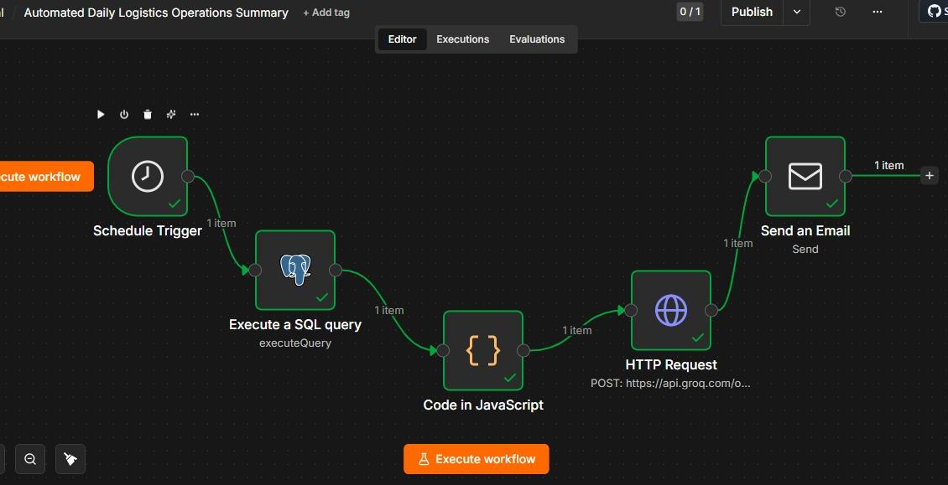

AI-Generated Daily Logistics Operations Email Report
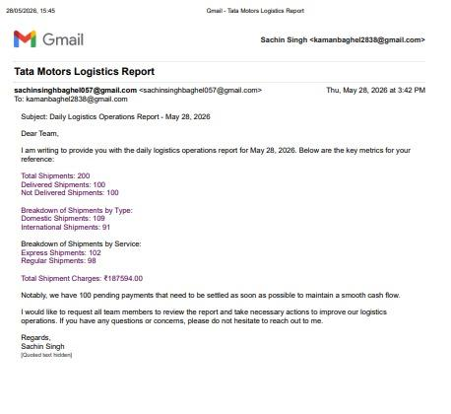

3.3.2 Problem Objective II — AI-Based Shipment & Payment Issue Explanation Automation

Problem Statement
Operations teams and customer support executives often require quick explanations for delayed shipments and unpaid orders. Manually checking shipment records, payment details, and employee assignments is time-consuming and inefficient.

Workflow Objective
The objective of this workflow is to automate shipment and payment issue explanations using n8n and GenAI. The workflow fetches shipment-related information and generates simple AI-based explanations for operational delays and payment issues.
n8n Workflow for Shipment & Payment Issue Explanation Automation
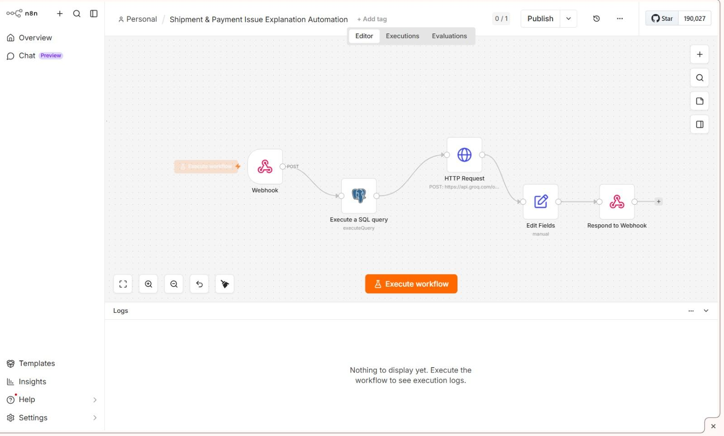

AI-Generated Shipment & Payment Issue Explanation Output
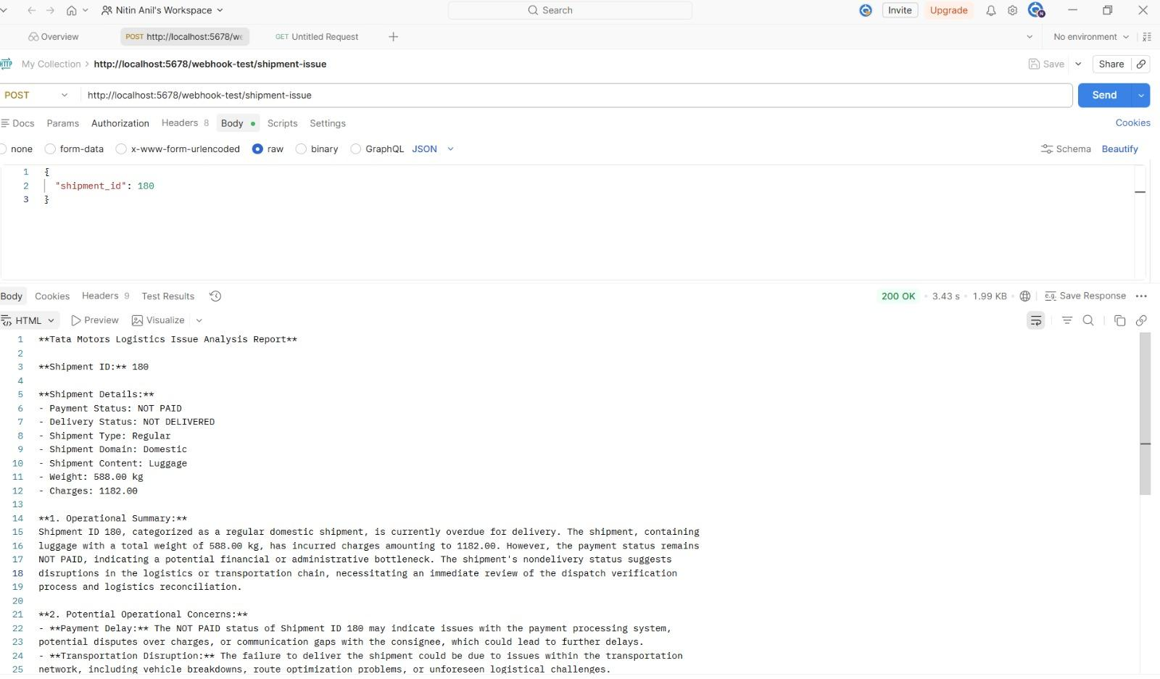

3.4 Key Insights & Business Impact Summary
1. Domestic Logistics Underperformance Domestic shipments take an average of 117.98 days to deliver compared to 96.26 days for international shipments. This counter-intuitive finding reveals significant inefficiencies in regional dispatch coordination, last-mile delivery management, and internal supply chain handoffs that require immediate operational attention.
2. COD Payment Dependency Poses Financial Risk Cash-on-Delivery transactions generate higher average values (₹49,578.86) than card-based payments (₹45,039.89), yet they remain unreconciled until physical delivery is confirmed. This creates cash flow uncertainty and increases the risk of payment default, particularly for pending international shipments.
3. Heavy Cargo Dominates Logistics Operations Over 60% of all shipments fall into the "Heavy Cargo" category (above 500 weight units), increasing transportation complexity, vehicle load pressure, and warehousing costs. Without specialized fleet allocation, this creates bottlenecks across the logistics chain.
4. Retail Customers Drive Revenue Concentration Retail customers account for approximately 39% of the total customer base and generate the highest revenue share. However, a large portion of memberships in this segment are expired, signaling poor retention and a missed opportunity for recurring revenue.
5. HR and Management Divisions Incur Disproportionate Shipment Costs Designation-level analysis revealed that HR Managers generate the highest average shipment charges (₹1,129.00), significantly above operational norms. Without cost monitoring controls, administrative functions inflate total logistics expenditure unnecessarily.
6. Predictive Maintenance Can Reduce Downtime by ~45% Combining IoT sensor monitoring, ML-based failure prediction, and automated alerts is estimated to reduce manufacturing downtime by 40–45%, directly contributing to an 8% profitability improvement.
7. Supply Chain Digitization Delivers 20–30% Cost Reduction Digitizing the supply chain through real-time inventory tracking, demand forecasting, and just-in-time systems can reduce inventory holding costs by 20–30% over five years, improving working capital efficiency significantly.

3.5 Conclusion
This project delivered a complete, end-to-end integrated operations analysis of Tata Motors — spanning business understanding and database design, SQL ETL and Excel EDA, and Power BI dashboarding with GenAI automation.
The team designed a scalable nine-entity relational schema, built a functional SQL ETL pipeline processing seven operational datasets, and performed Excel-based exploratory analysis that surfaced critical findings around domestic delivery delays, COD dependency, heavy cargo concentration, and logistics cost variations. These insights were operationalized through an interactive Power BI dashboard and two n8n GenAI automation workflows — eliminating manual reporting and enabling instant AI-driven explanations for shipment and payment issues.
Across all analytical layers, the project proposed strategies estimated to deliver 26% profitability growth for Tata Motors through predictive maintenance, defect reduction, inventory optimization, EV expansion, and supply chain digitization. This demonstrates how a structured analytics pipeline — from raw data ingestion to business intelligence to AI-powered automation — can transform manufacturing and logistics operations into a proactive, insight-driven ecosystem ready for real-world deployment.

